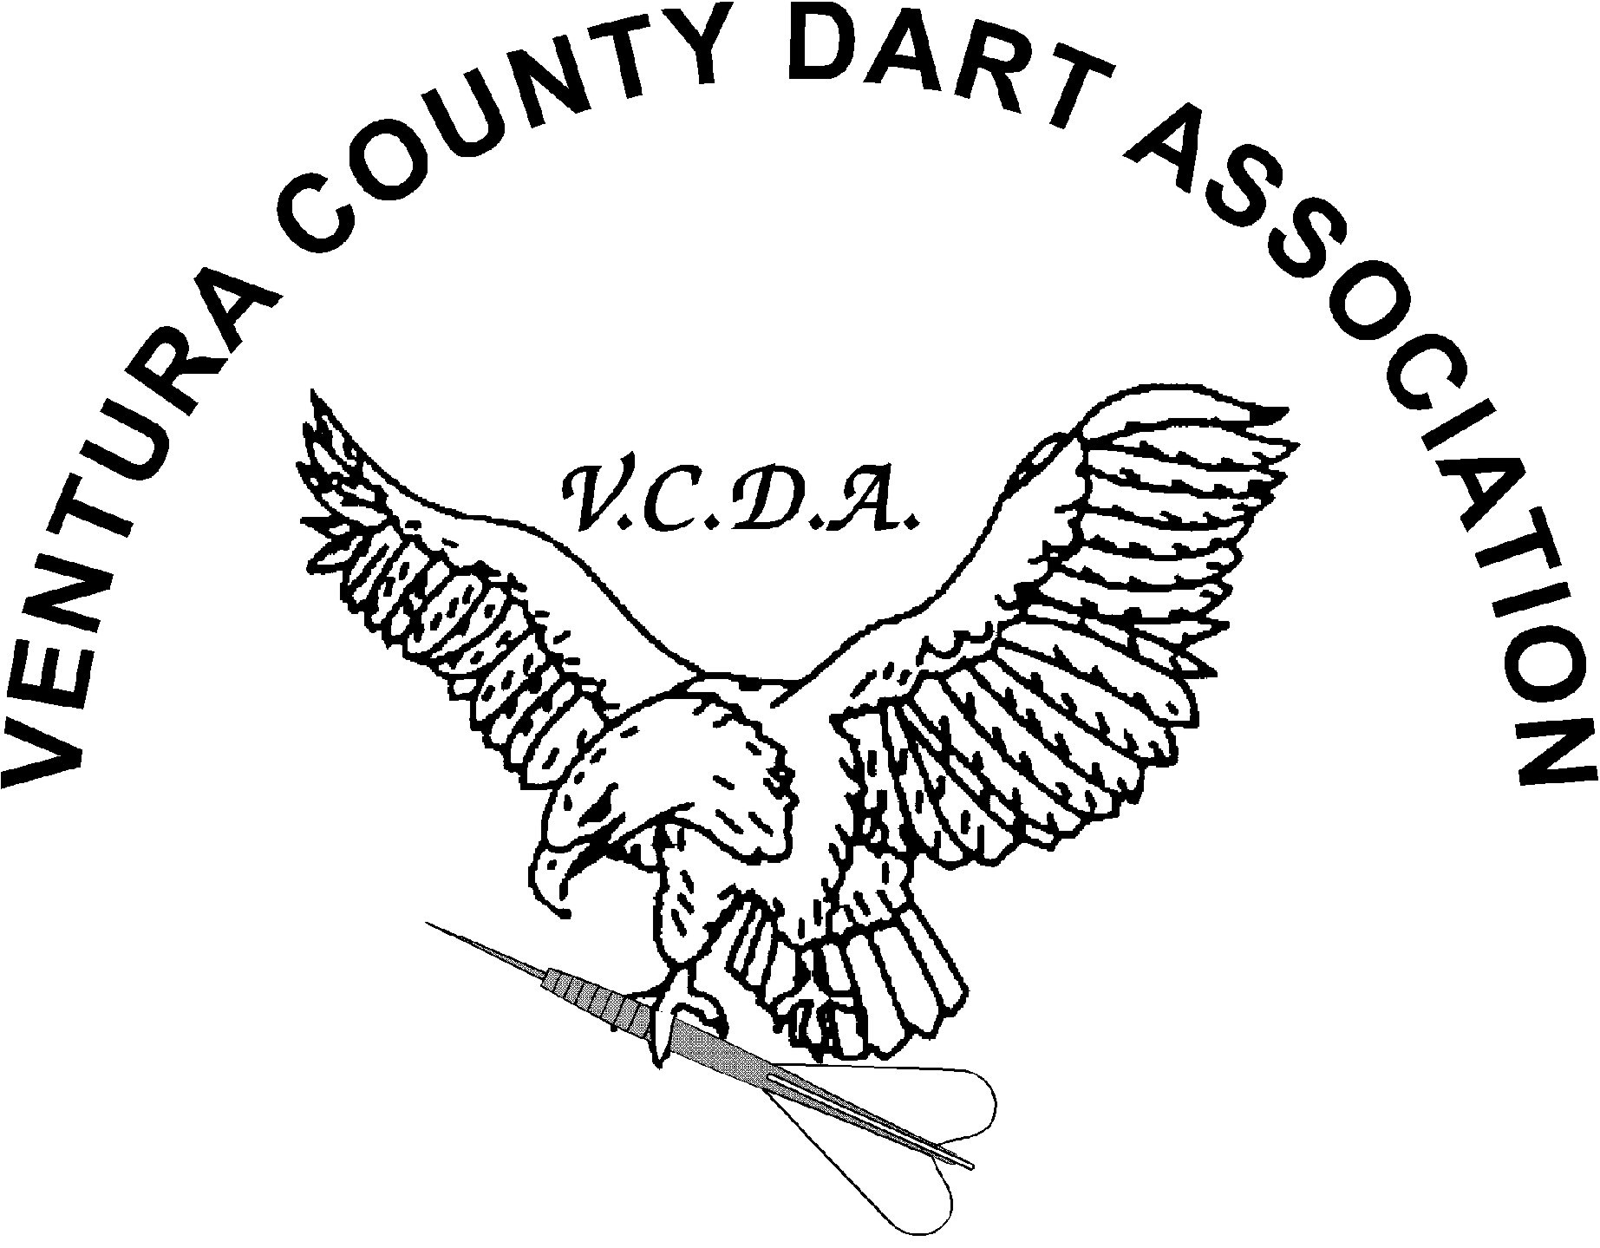

Gold Coast Shootout VI $1,070.00 Guaranteed Prize money
When: Saturday March 14 2015
Where: Palm Garden Hotel, Address: 495 Ventu Park Rd, Thousand Oaks, CA 91320
Start: Registration Starts at 9:00 AM and Closes at 9:30AM (Sharp)
ADO Sanctioned event

Draw Doubles Chicago | Mixed Doubles Cricket X | Men’s Singles 501* | Women’s Singles 501*
10:00 AM  $10 per player | 12:00 PM  $10 per player | 2:00 PM  $20 per player | 2:30 PM  $20 per player
1st Place- $100 | 1st Place- $100 | 1st Place- $150 | 1st Place- $100
2nd Place- $60 | 2nd Place- $60 | 2nd Place-$80 | 2nd Place-$50
T4- $40 | T4- $40 | T4- $40 | T4-$25
 |  | T8-$20
$240 | $240 | $390 | $200

*= ADO Surcharge included
X= Women players will be recycled as needed
Any questions contact Bryan Gosser (805) 302-6936
DPLA Event on Saturday 3/14/2015 Start Time 4:00 PM Cost $50.00 for the men and $25 for the Women Contact Dave Irete (213) 369-7324

