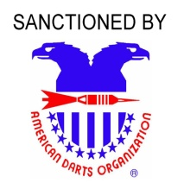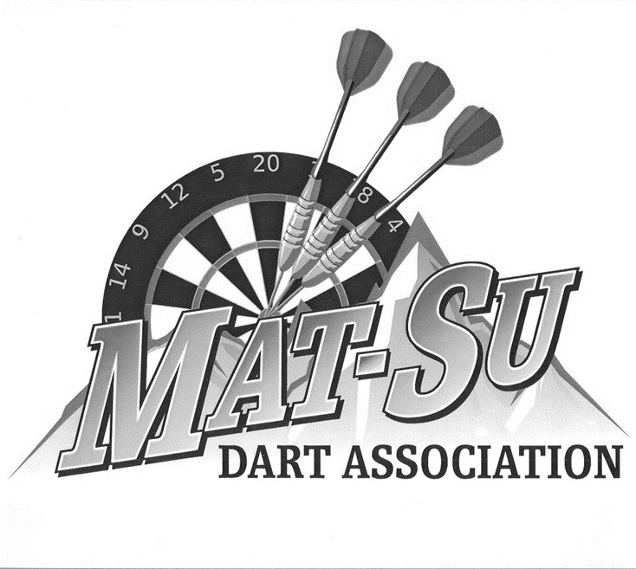

Hosted by:

American Legion Post 35

5050 Tweed Ct.

Mile 46 Parks Hwy.

Wasilla, AK 99654

907-376-3500

*Non-Smoking Venue*



Day

Time

Friday

7pm

Saturday

10 am

Saturday

2 pm

Saturday

2:30pm

Saturday

6:30 pm

Saturday

7:00 pm

Sunday

10 am

Sunday

10:30 am

Event

Blind

Draw

Doubles

501

SO/DO

Mixed

Doubles

501

SO/DO

Women's

Singles

Cricket

Men's

Singles

Cricket

Women's

Doubles

501

SO/DO

Men's

Doubles

501

SO/DO

Women's

Singles

501

SO/DO

Men's

Singles

501

SO/DO

Fee

$15 Per

Player

$30/team

* $20

* $20

$30/team

$30/team

* $20

* $20

1st

$300

$250

$200

$250

$250

$300

$250

$300

2nd

$150

$130

$100

$125

$130

$150

$125

$150

3rd/4th

$80

$70

$50

$70

$70

$80

$65

$75

5th-8th

$40

$20

$20

$20

$30

$30

$20

$20

Total

$770

$600

$480

$595

$640

$730

$585

$680

Best Western (907) 373-1776

Wind Break (907) 376 - 4484

***Carrie Keays***

**(907) 841-3125**

**ADO National Cricket**

**Qualifier**

**Registration closes 15 minutes prior to each Event's start times!**

**12:00 noon, Nov 6, 2015**

**For more informations**

**contact: Tournament**

**Director**

Hotel Information: Special

Rates at Grandview Inn for

Darters (907) 357-7666

**\* Includes a $2 ADO Fee**