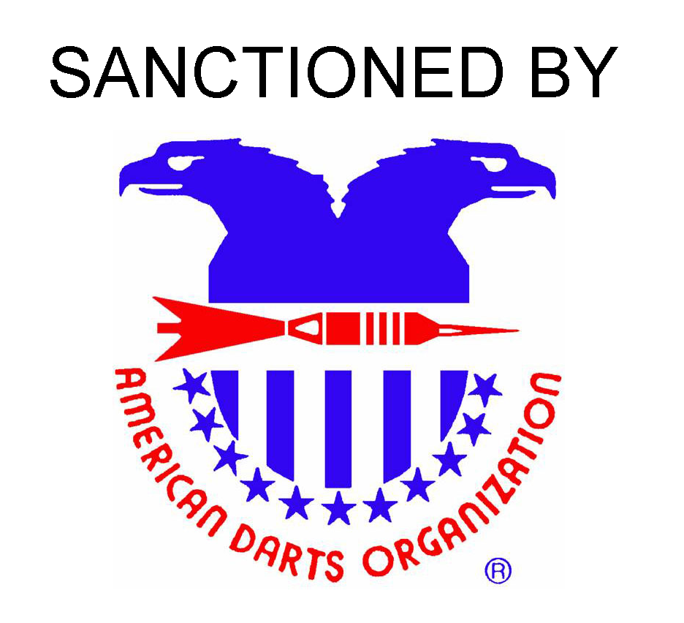

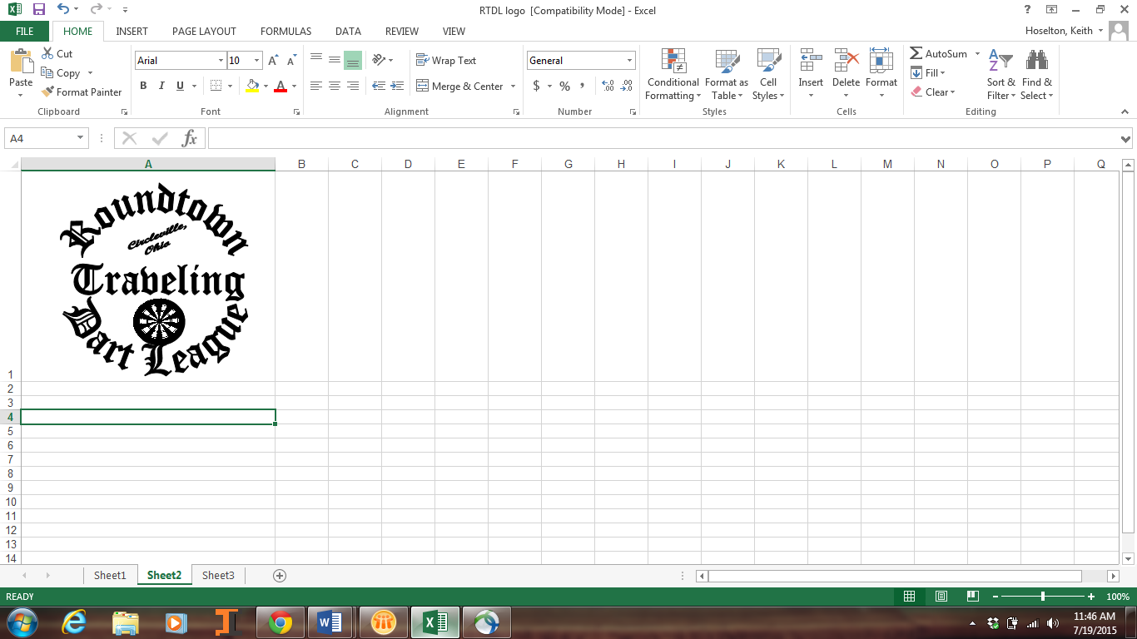

$15,000+  
December 2nd & 3rd 2016

Buckeye Open XXXIV

Hosted by The R.T.D.L  
Home of the Quad City Challenge

|  |  |  |  |  |  |  |  |  |  |  |
| --- | --- | --- | --- | --- | --- | --- | --- | --- | --- | --- |
| Event | *Men’s  Singles  Cricket | *Ladies’  Singles  Cricket | Blind  Draw  501 | Men’s  Doubles  501 | Ladies’  Doubles  501 | Ladies’  Doubles  Cricket | Men’s  Doubles  Cricket | *Ladies’  Singles  501 | *Men’s  Singles  501 | Mixed  Triples  601 |
| Time | 6:30 P.M. | 7:00 P.M. | 9:00 P.M. | 10:00 A.M. | 11:00 A.M. | 1:00 P.M. | 1:30 P.M. | 4:00 P.M. | 4:30 P.M. | 8:00 P.M. |
| Entry Fee | *$20 | *$20 | $15 | $30 | $30 | $30 | $30 | *$20 | *$20 | $45 |
| 1st | $600 | $300 | $450 | $550 | $300 | $300 | $550 | $300 | $600 | $510 |
| 2nd | $300 | $150 | $230 | $280 | $150 | $150 | $280 | $150 | $300 | $270 |
| Top 4 | $150 | $75 | $120 | $140 | $80 | $80 | $140 | $75 | $150 | $150 |
| Top 8 | $75 | $40 | $80 | $70 | $44 | $44 | $70 | $40 | $75 | $90 |
| Top 16 | $40 | $20 | $60 | $44 |  |  | $44 | $20 | $40 | $45 |
| Top 32 | $20 |  | $40 |  |  |  |  |  | $20 |  |
|  | $2140 | $920 | $2360 | $1742 | $786 | $786 | $1742 | $920 | $2140 | $1800 |

Tournament Director: Joey Hoselton khoselto@columbus.rr.com  buckeyeopen@gmail.com Join Buckeye Open on Facebook for updates!



Registration closes at the above times.

*Singles Event Registration Amounts Above Do Include ADO Surcharge

All matches best 2 0f 3

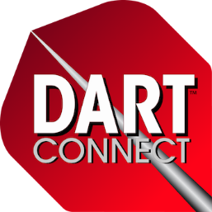

Dart Supplies By

[dartrunners@columbus.rr.com](mailto:dartrunners@columbus.rr.com)

Rev.7/5/16

Full service bar for the Dart Halls. Absolutely NO carry in ALCOHOL or MUGS permitted in the Dart Hall.

Proudly located at the   
Crown Plaza Dublin!  
600 Metro Place North  
Dublin, Ohio 43017  
1-614-764-2200

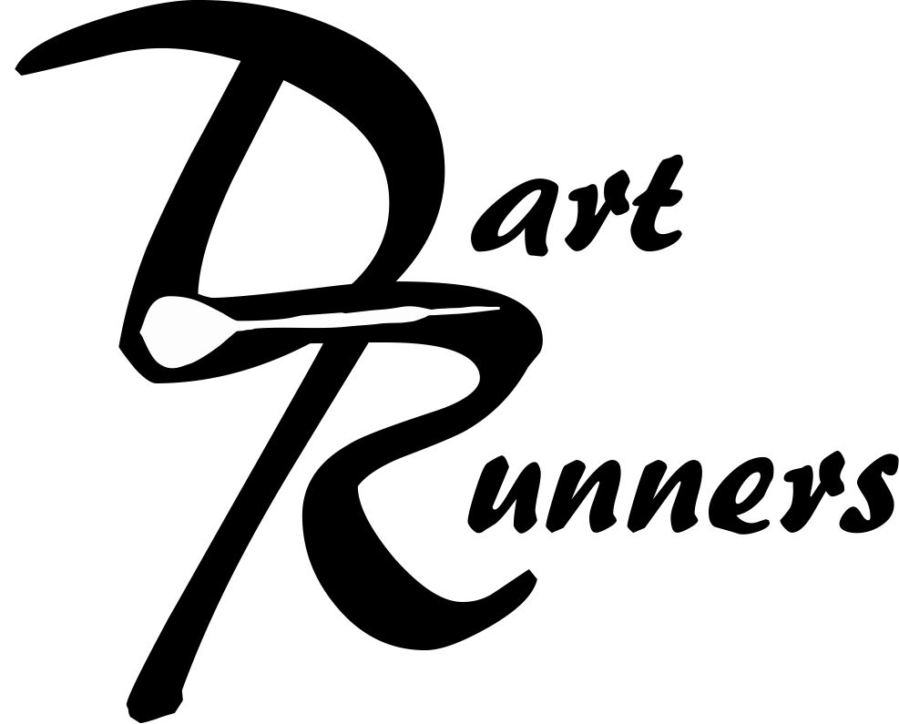

Enhanced chalking experience provided by

DartConnect – Perfect Your Game!

Limited tablets available

www.dartconnect.com

Special Darter Rates: $87/night double occupancy.

$20 / person each additional person

Book by November 1, 2016  
Limited rooms available, book early. Just ask for “Darters Rate”