Palm Beach County Darting Association

11th Annual Palm Beacher

$2000

May 3rd, 2025

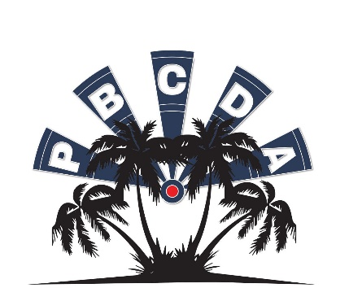

*$1.00 FDA & $2.00 ADO per singles entry included. A Processing Fee May Apply. Steel Tip Darts Only.

|  |  |  |  |  |  |  |
| --- | --- | --- | --- | --- | --- | --- |
| **EVENT** | **MIXED DOUBLES 501** | **MEN’S** **DOUBLES** **CRICKET** | **LADIES** **DOUBLES** **CRICKET** | **OPEN SINGLES CRICKET\*** | **MEN’S SINGLES** **501\*** | **LADIES** **SINGLES** **501\*** |
| **TIME** | **10:30am** | **12:00pm** | **12:30pm** | **2:30pm** | **5:00pm** | **5:30pm** |
| **ENTRY** | **$30\*** | **$30** | **$30** | **$20** | **$20\*** | **$20\*** |
| **1ST** | **$250** | **$176** | **$120** | **$175** | **$150** | **$120** |
| **2ND** | **$150** | **$102** | **$70** | **$105** | **$90** | **$60** |
| **3RD** **–** **4TH** | **$50** | **$36** | **$30** | **$45** | **$30** | **$25** |
| **TOTAL** | **$500** | **$350** | **$250** | **$370** | **$300** | **$230** |

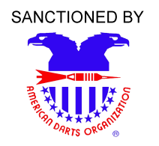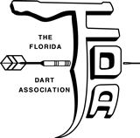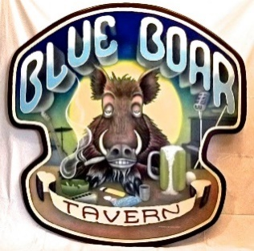

**\*Raffle Baskets**

**\*50/50 Drawings**

**\*Lottery Tree**

**\*Proceeds benefit 2025 State Team**

**Note:**. **Entry** **fees** **are** **processing** **fees** **for** **tournament** **management,** **administration,** **and** **advertising.** **Prize** **monies** **are** **paid** **by** **the** **tournament** **sponsor** **and** **are** **not** **part** **of** **the** **processing** **fees. This** **meets** **the** **criteria** **of** **the** **Florida** **Gaming** **Laws.** **Prize** **monies** **are** **guaranteed** **by** **PBCDA.**. **Registration** **cutoff** **15** **minutes** **before** **each event.**

Tournament Director: Susan Wilson 561-313-2219 [Susanwinfl@yahoo.com](mailto:Susanwinfl@yahoo.com)

**Location:**

Blue Boar Tavern  
 1306 North Military Trail  
 West Palm Beach Florida, 33409  
 (561) 686-3865