^{10th}Annual Margie O’Donoghue Memorial Tournament
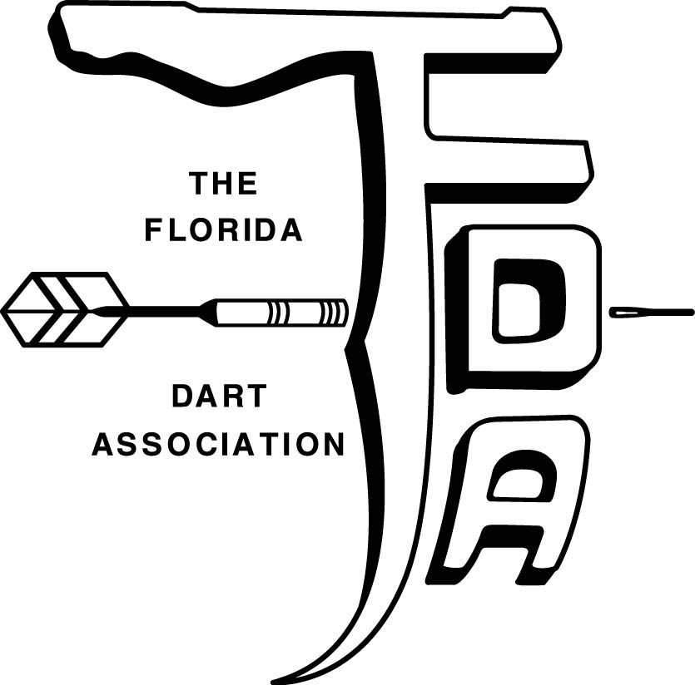
$5000
April 22nd & 23rd 2023
**$1 FDA Fee per Event/$2 ADO Fee per Singles Event** Posted Time is Close of Registration Steel Tip Darts Only
Saturday |  |  |  |  |  | Sunday
 | Mixed  Doubles  501 | Men’s  Doubles  501 | Ladies  Doubles  501 | **Ladies  Singles  Cricket** | **Men’s  Singles  Cricket* |  | Mixed Doubles Cricket | Men’s  Doubles  Cricket | Ladies Doubles Cricket | **Ladies  Singles  501 ** | **Men’s  Singles  501 **
Time | 11 AM | 1 PM | 2 PM | 4 PM | 4:30 PM | Time | 11 AM | 1 PM | 2 PM | 4 PM | 4:30 PM
Entry Fee | $30 | $30 | $30 | $20 | $20 | Entry Fee | $30 | $30 | $30 | $20 | $20
1st | $300 | $300 | $250 | $160 | $220 | 1st | $300 | $300 | $250 | $160 | $220
2nd | $160 | $160 | $130 | $100 | $110 | 2nd | $160 | $160 | $130 | $100 | $110
3rd – 4th | $70 | $70 | $60 | $45 | $60 | 3rd – 4th | $70 | $70 | $60 | $45 | $60
Total | $600 | $600 | $500 | $350 | $450 | Total | $600 | $600 | $500 | $350 | $450

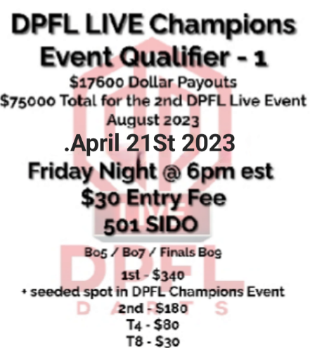 | Tournament Location  14736 Edward R Noll Dr, Spring Hill, FL 34609  (352) 796-0398  BLIND DRAW FRIDAY  April 21st @8:30pm  $10 entry  **DPFL EVENT NOT SANCTIONED BY THE FDA OR ADO** | Lodging  Quality Inn  9373 Cortez Blvd  Spring hill FL 34613  (352)596-9000  Holiday Inn Express & Suites Brooksville West  14112 Cortez Blvd  Brooksville FL 34601  (352)597-4540  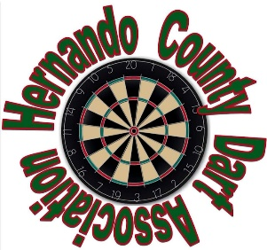 | Tournament Director  Ashlie Marcus  (616)308-9732  Email: ashrenee1986@gmail.com  ENTRY FEES ARE PROCESSING FEES FOR  TOURNAMENT MANAGEMENT, ADMINISTRATION AND ADVERTISING. PRIZE MONEYS ARE PAID BY THE TOURNAMENT SPONSORS AND ARE NOT PART OF THE PROCESSING FEES. THIS MEETS THE CRITERIA FOR THE FLORIDA GAMING AND BEVERAGE LAWS.  PROCEEDS GO TO HCDA STATE TEAM.

